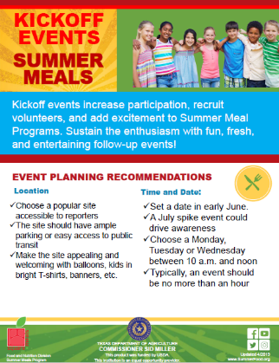
Kickoff Event Tips Toolkit Learn how to plan, promote and host a successful summer kickoff event.

"S:\Program Advancement\Food Systems and Program Engagement\02 FY24\02 Projects\13 Summer Meal Programs\Resources\Summer Kickoff Event Toolkit_Final.pdf"

